**Software Engineering Tools Lab Assignment No-9**

(Module 5- Software testing using tools) **Due date-20/04/2023**

Q 1. What are the prerequisites for installing the Selenium.

To install Selenium, you need to have the following prerequisites:

* A programming language: Selenium supports multiple programming languages such as Java, Python, C#, Ruby, JavaScript, etc. You should have a working knowledge of at least one of these programming languages to use Selenium.
* A web browser: Selenium automates web browsers, so you need to have a web browser installed on your computer. Selenium supports multiple browsers, including Google Chrome, Mozilla Firefox, Microsoft Edge, and Safari.
* Eclipse IDE
* Selenium language-specific Client Driver (JAVA)
* Selenium Server
* Web driver: You also need to have the web driver for the specific browser(Google Chrome) you want to automate. The web driver is a separate executable that needs to be downloaded and installed for each browser. The web driver acts as a bridge between the Selenium script and the browser.
* Selenium WebDriver libraries: Finally, you need to install the Selenium WebDriver libraries for the programming language you are using. These libraries provide the necessary APIs to write and run Selenium scripts in your chosen programming language.

Overall, the installation process for Selenium can vary depending on your programming language and the web browser you want to automate, but these are the general prerequisites you need to have.

Q 2. Install Selenium tool on your machine (Provide screen shots for successful installation and login)

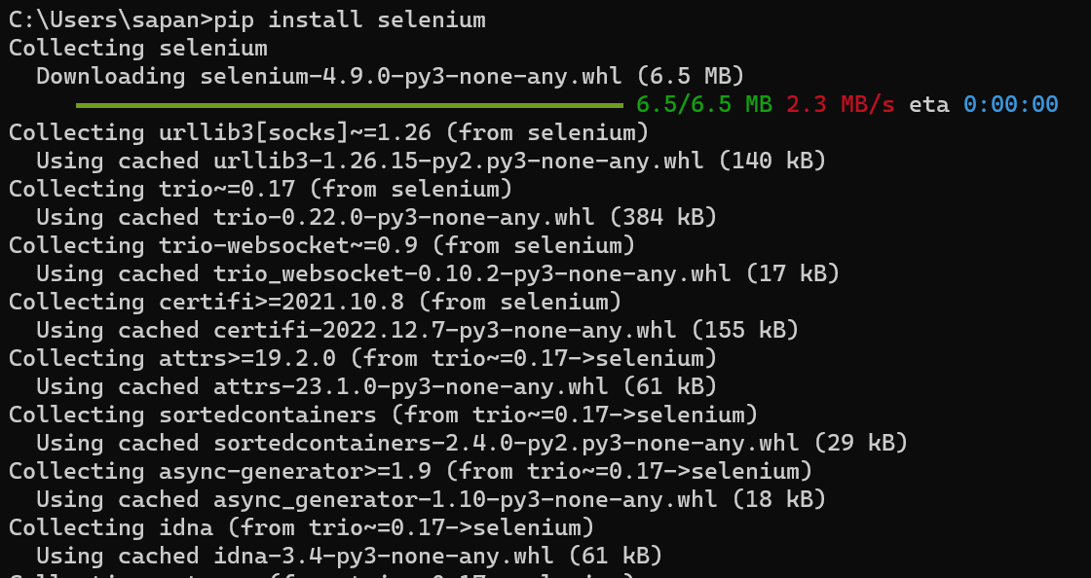

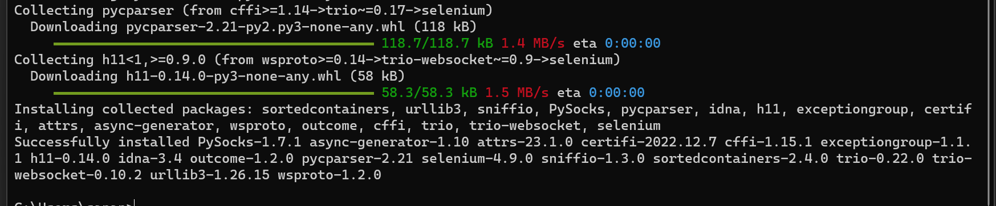

Q 3. Using Selenium tool create multiple test cases (at least 10) on any application/project that you have implemented.

Perform below tasks

1. Create New test project as SETProject

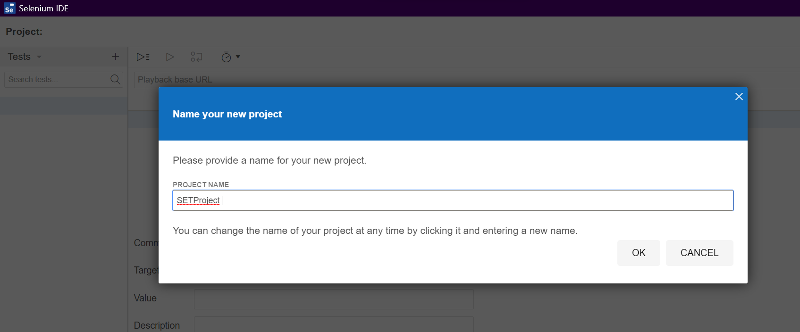

1. Create a test plan as SETProjectTestPlan

1. Create a build as SETProjectBuild

1. Create test suite as Test Suite 1 under SETProject

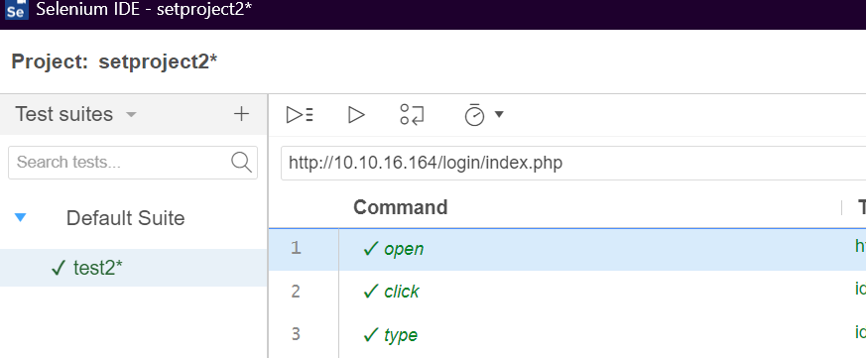

1. Create Test cases in Selenium Tool

Automating execution of tests using extensions -

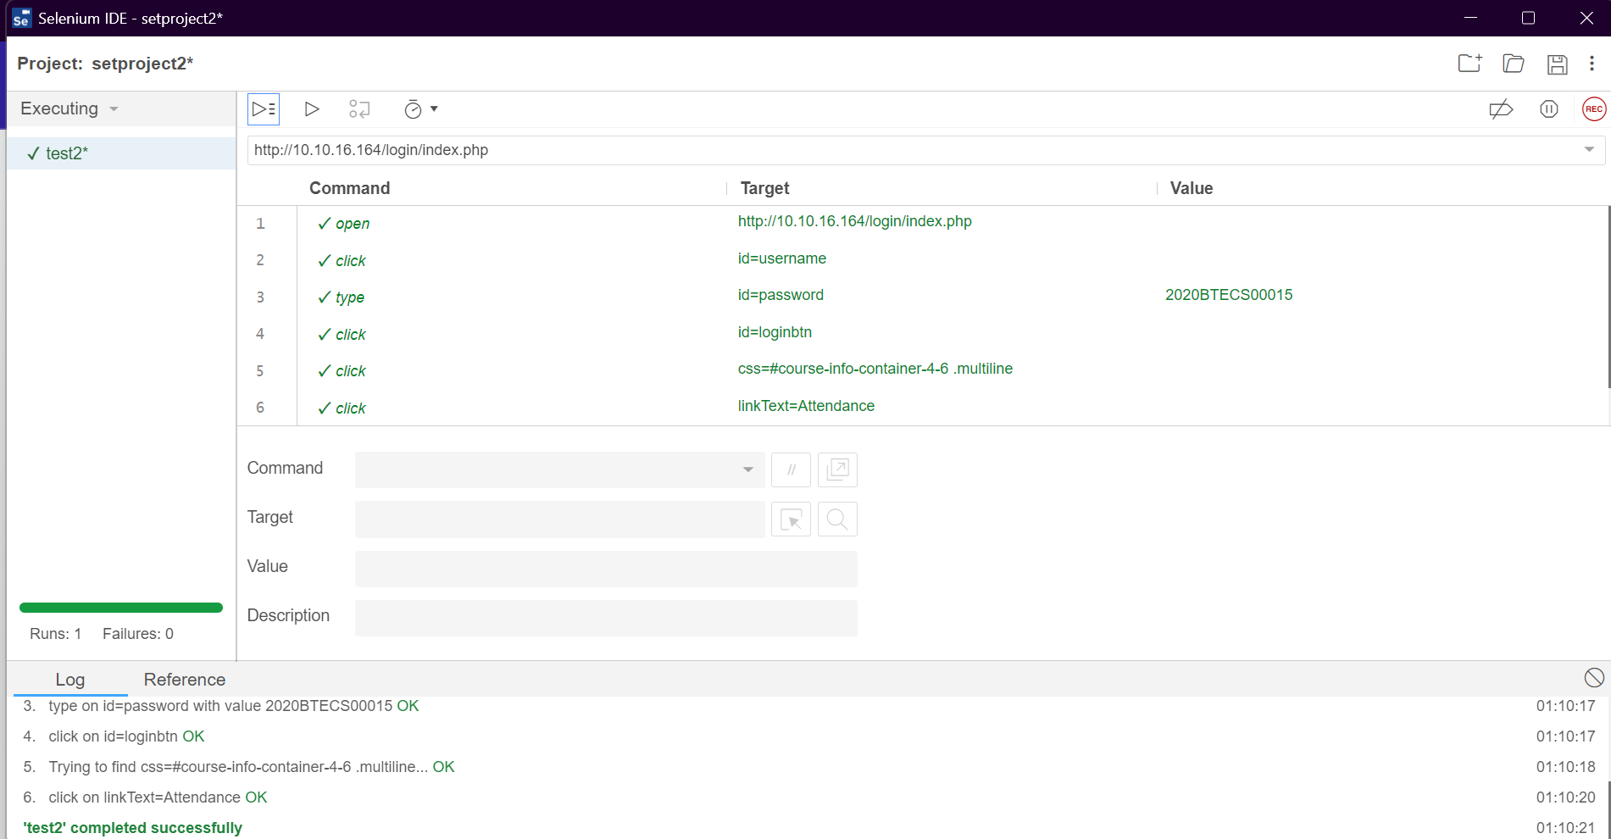

Automating execution of tests using python code -

Test to check login with a username and password on submission portal

